Lab: App Monitoring
Lab for the "Containers and Clouds" course @ SoftUni

Prometheus and Blackbox Exporter: Run Prometheus Server that Monitors SoftUni.org
Our task is to configure Prometheus to monitor https://softuni.org. In order for this to happen, we shall use the Prometheus Blackbox Exporter.
Prometheus Blackbox Exporter is designed to probe various endpoints and expose the results as metrics that Prometheus can scrape.
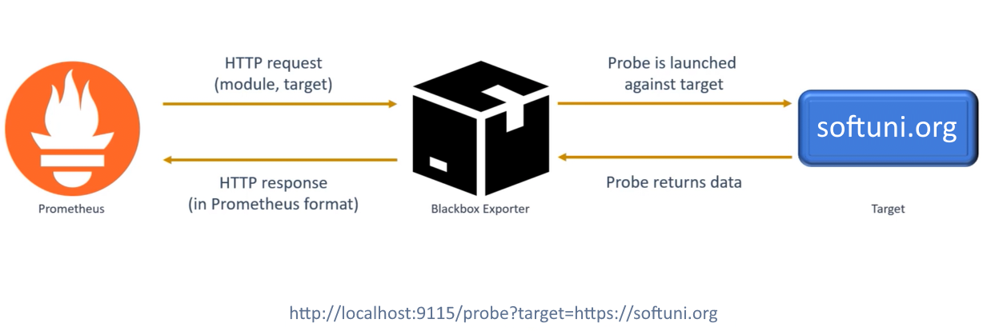

Step 1: Install and Run Blackbox Exporter
To use the Blackbox Exporter, let's run it in a Docker container and expose its port:
Navigate to the exporter URL in the browser with the correct target:
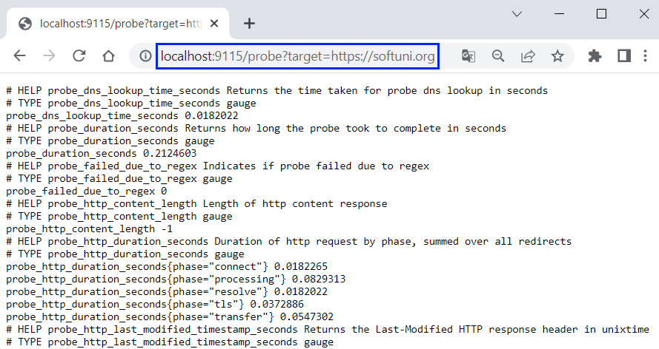

Step 2: Blackbox Exporter Metrics
If you access https://softuni.org (without caching), it responds for about 23 seconds:
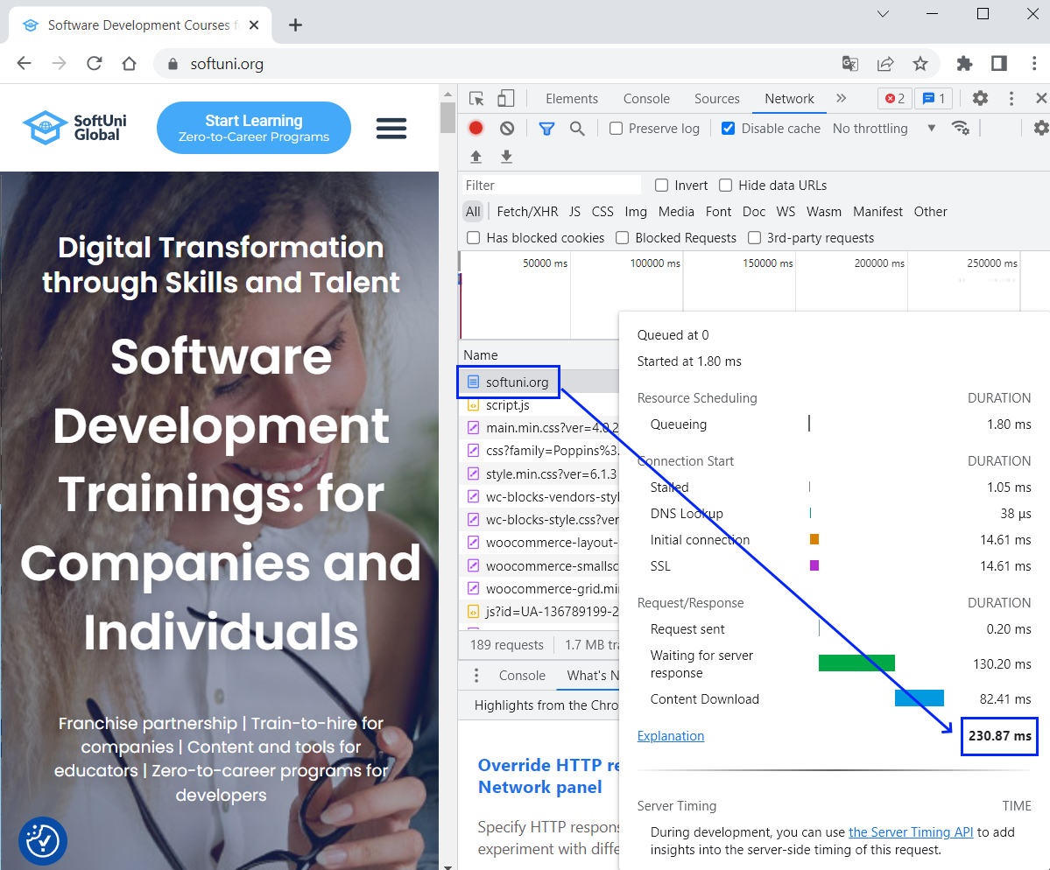
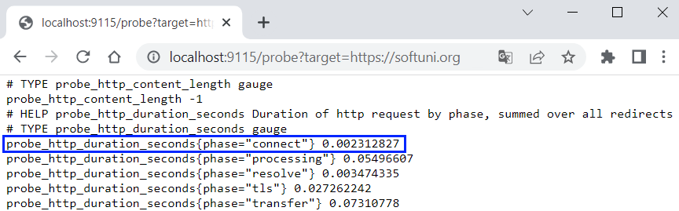
NOTE: Values may differ but they should be close enough to one another.

Step 3: Configure and Run Prometheus
Now we should configure Prometheus to use the Blackbox Exporter metrics.
First, let's create a Prometheus configuration YAML file in the installation directory:
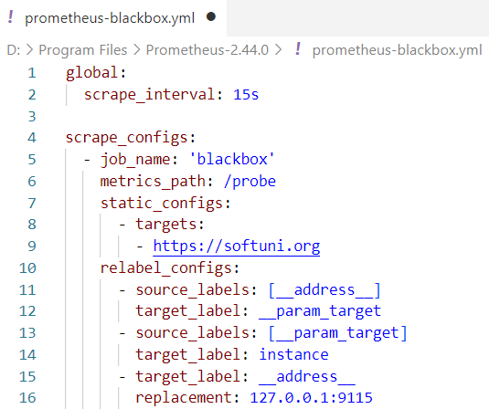
- scrape_interval: 15s
  - Target is being scraped each 15 seconds
- metrics_path: /probe
  - Metrics can be accessed on /probe
- - targets:
- https://softuni.org
  - Define the targeted site URL
- Replacement: 127.0.0.1:9115
  - Blackbox exporter's hostname:port
Then, let's start Prometheus server with the configuration file:

Step 4: Access Prometheus
Now, let's access Prometheus on http://localhost:9090
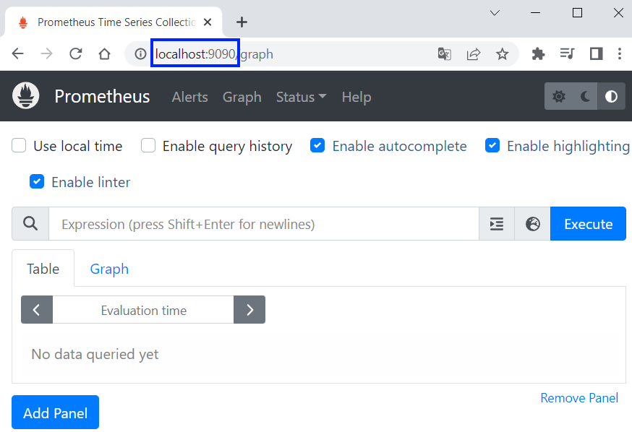
We can look at the target site status from [Status] → [Targets]:
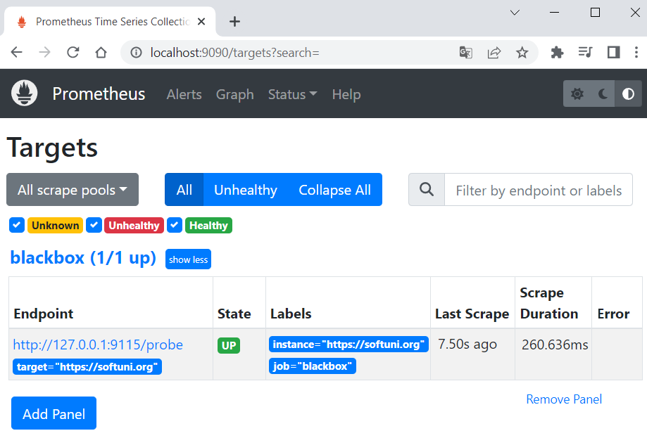

Step 5: Examine Metrics
Prometheus graphs are used to visualize the metrics collected and help you understand how systems are performing over time.
In order to look at Prometheus graph, navigate to [Graph], choose a metric to visualize and click [Execute]. From there you can switch from [Table] to [Graph], where you can examine the visualization:
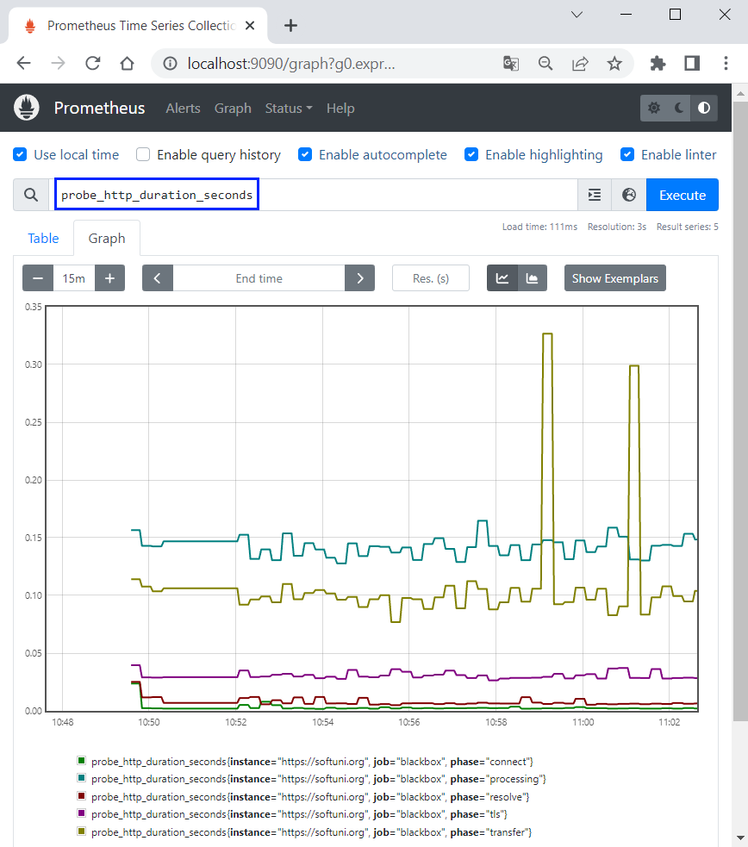

Prometheus and Alertmanager
In this task, we will create alerts for Prometheus Metrics. If the connection to SoftUni.org takes more than 25 milliseconds, we want to fire an alert to Alertmanager. Then, Alertmanager should forward alerts to a webhook on Webhook.site. Everything, that is sent to it, should be shown instantly.

Step 1: Prometheus, Blackbox Exporter and Webhook
First, run Prometheus and Blackbox Exporter again.
Then, open Webhook.site and copy your unique URL for the Alertmanager configuration:
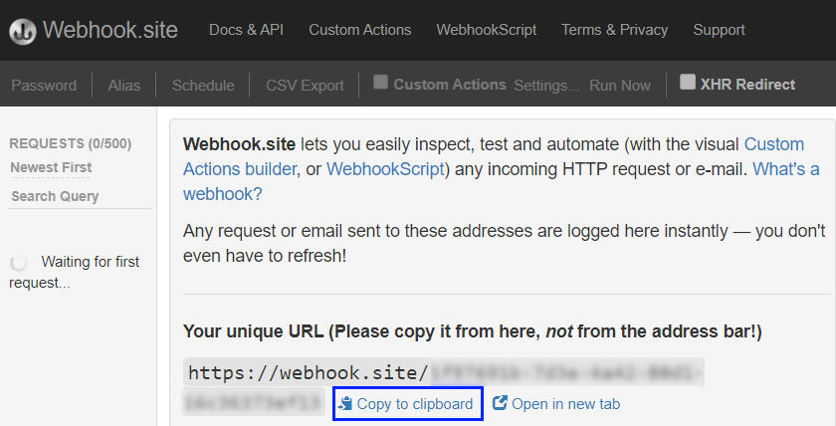

Step 2: Configure Alertmanager
Now, let's create a YAML file in the Alertmanager directory:
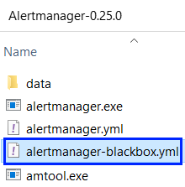
The configuration should:
- Sets the timeout for alert resolution to 5 minutes
- Specifies that alerts are sent to the "webhook_receiver" receiver
- Configures the "webhook_receiver" receiver
  - It should send requests to the URL that Webhook.site provided
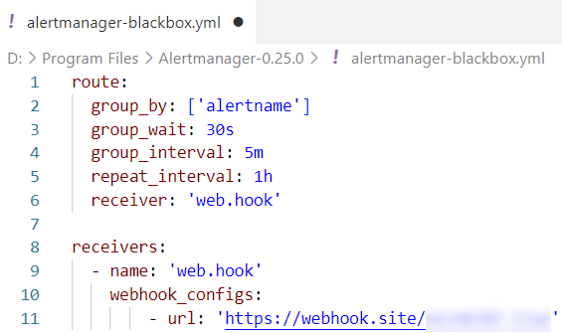

Step 3: Configure Alerting Rules
Now, we need to configure the alerting rules, which means that we have to add rules to the Prometheus configuration. In order to do that, create a YAML file in the Prometheus directory:
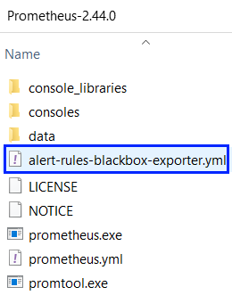
Create the file like this:
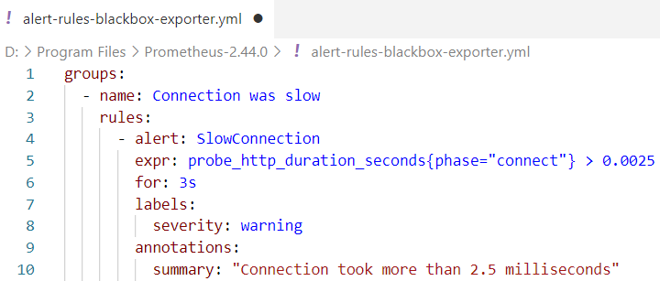
- - name: connection was slow
  - The name of the rule group
- - alert: SlowConnection
  - The name of the alert
- expr: probe_http_duration_seconds{phase="connect"}
  - the Prometheus expression that defines the condition for firing an alert. In this case, the duration of the "connect" phase during an HTTP probe
- for: 3s
  - the minimum time for the expression to be true, in order to fire an alert
- labels:
severity: warning
  - the severity of the alert
- annotations:
summary: "Connection took more than 2.5 milliseconds"
  - the summary for the alert

Step 4: Configure Prometheus
Now, let's configure Prometheus. In order to do that, we need a Prometheus YAML configuration file. We can use the configuration from the previous demo and add:
- Evaluation interval to define rules evaluation intervals
- The name of the rules file
- Alerting section that defines the Alertmanager configuration. Keep in mind that Alertmanager is accessed on http://localhost:9093 (default URL).
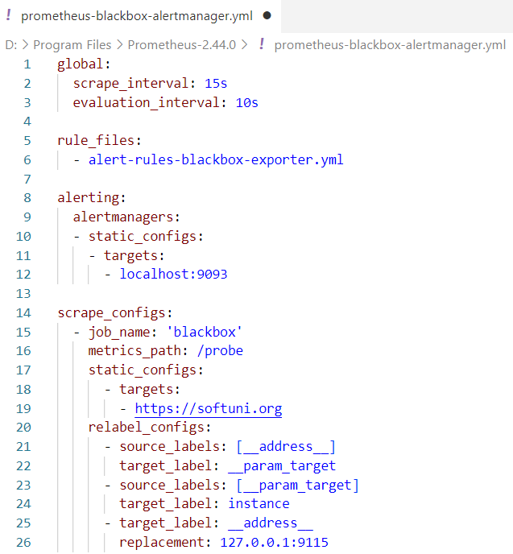

Step 5: Run Alertmanager and Prometheus
Now, start Alertmanager with the configuration file:
You can access it on http://localhost:9093:
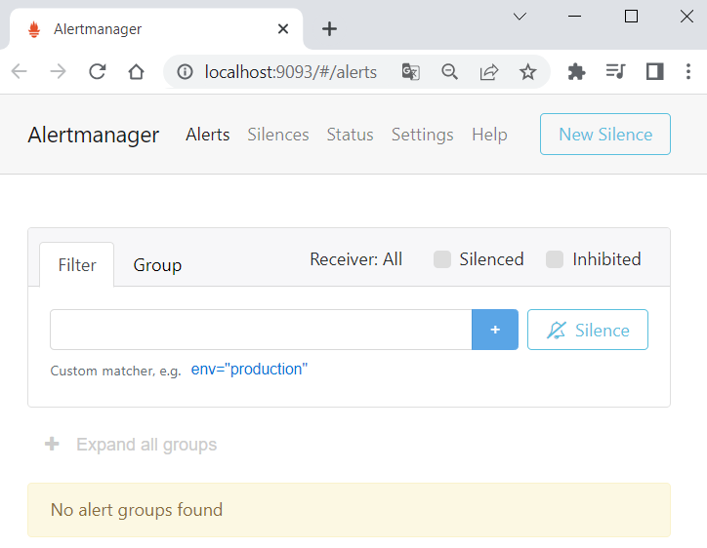
Next, start Prometheus, too:
You can access it on http://localhost:9090:
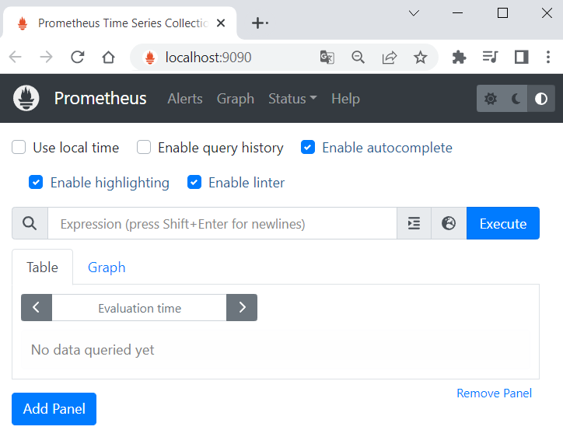

Step 6: Fire and Examine Alert in Prometheus
Navigate to [Alerts] in Prometheus and look at the inactive alert:
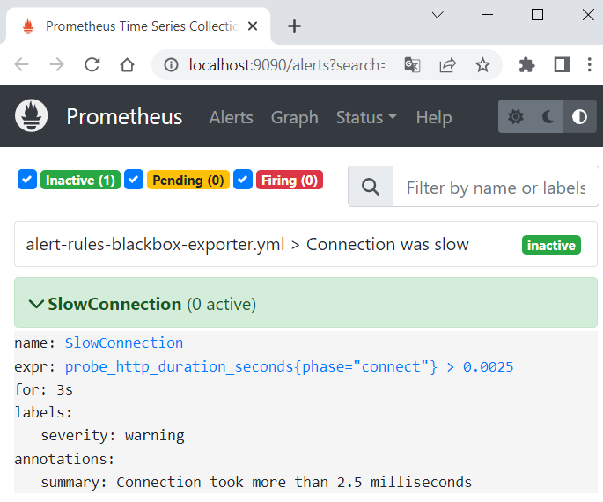
You can look at metric values to see when it exceeds 0.0025. This will be when the alert is fired:
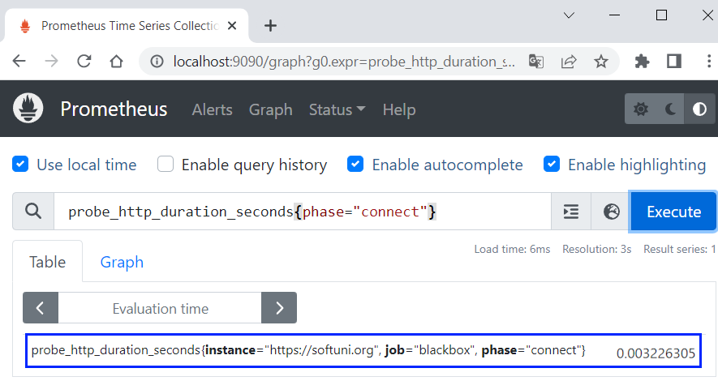
Wait for 3 seconds for the alert to be fired and refresh the page. It should be pending:
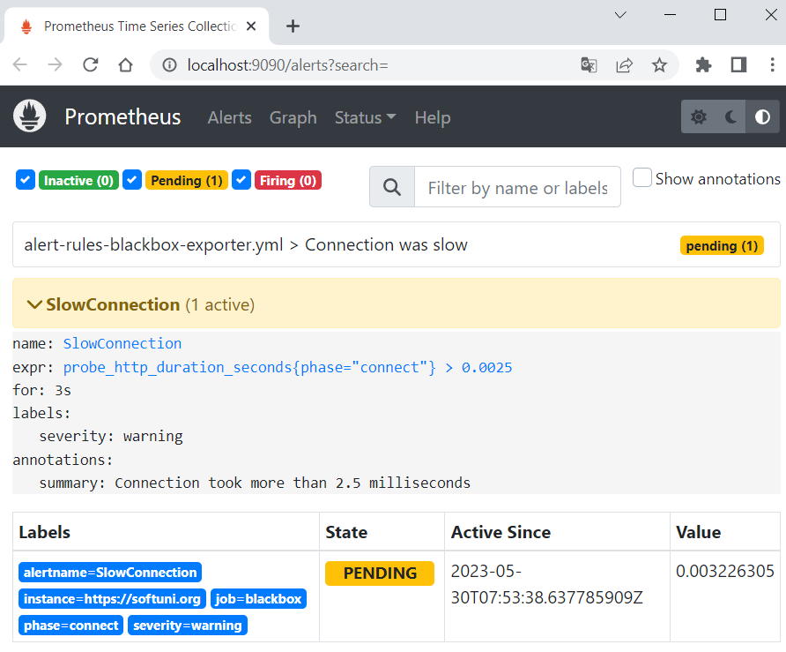
On refresh, the alert should be firing. It will become inactive again when the metric value is <= 0.0025:
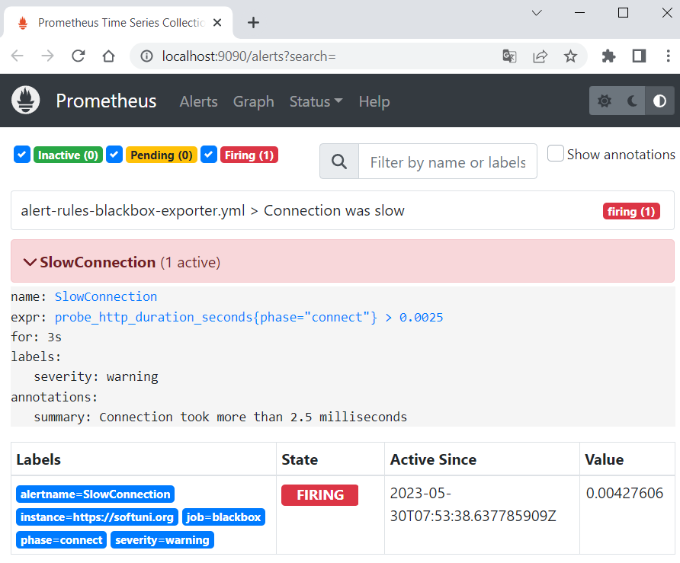

Step 7: Examine Alert in Alertmanager and Webhook
Now, let's go to Alertmanager and we should see the fired alert:
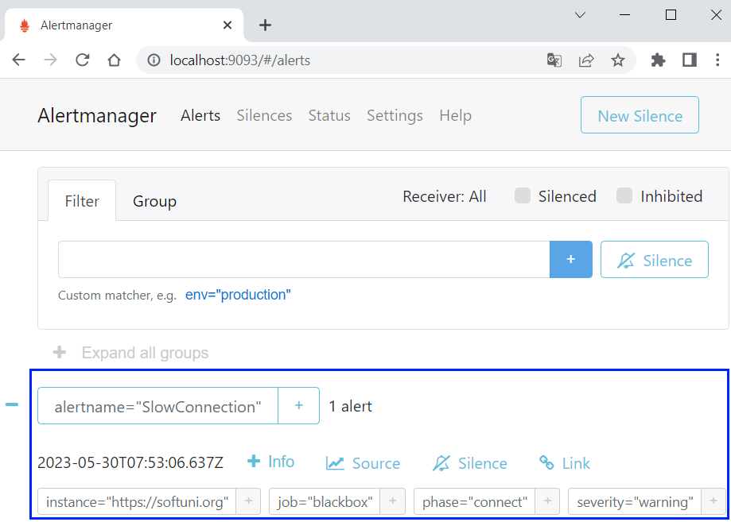
It should also be forwarded to the Webhook.site:
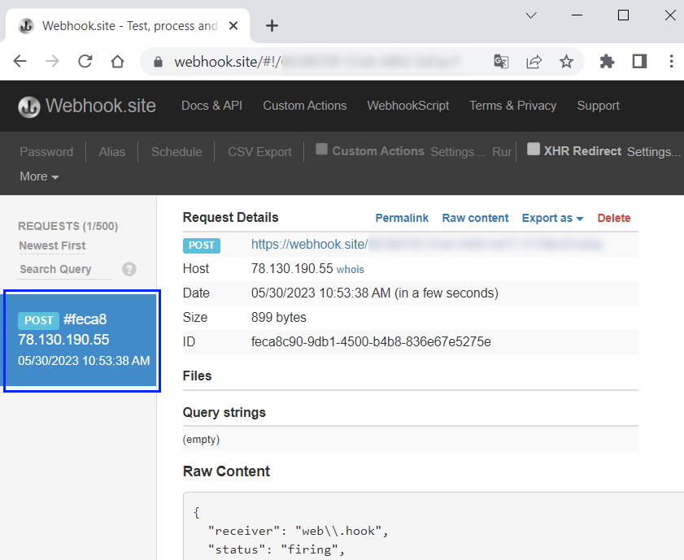

Grafana and Prometheus

Step 1: Log in to Grafana
By default, Grafana will be listening on http://localhost:3000. You can log in with the default credentials:
- Email or username: admin
- Password: admin
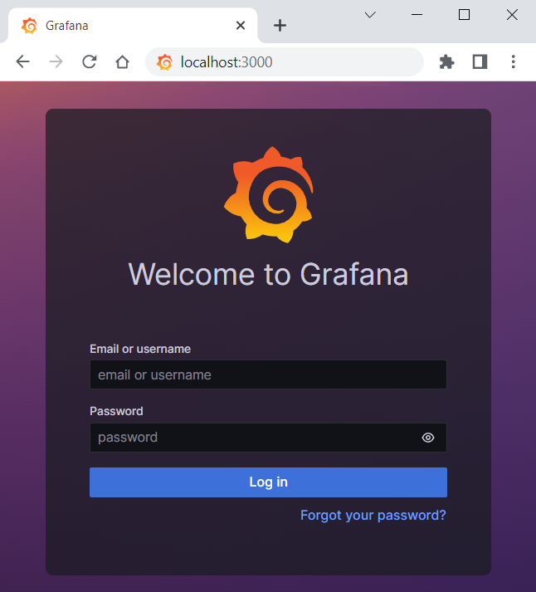
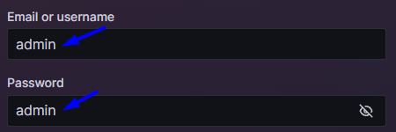
After entering the credentials, you will be asked to set a new password. You can do that, or you can just skip this step.
Then, you will be redirected to the Welcome page:
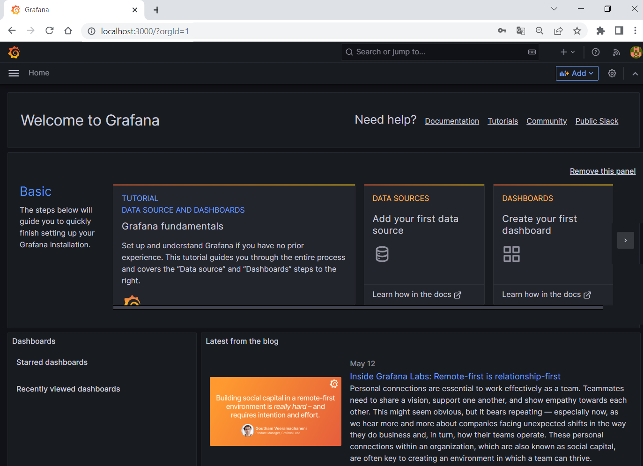

Step 2: Create Prometheus Data Source in Grafana
Open the sidebar on the left and go to [Connections]:
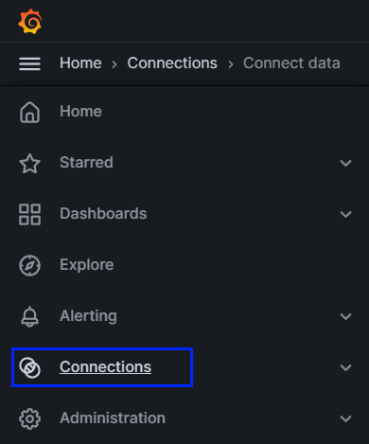
Then, search for "Prometheus" data source and click on it:
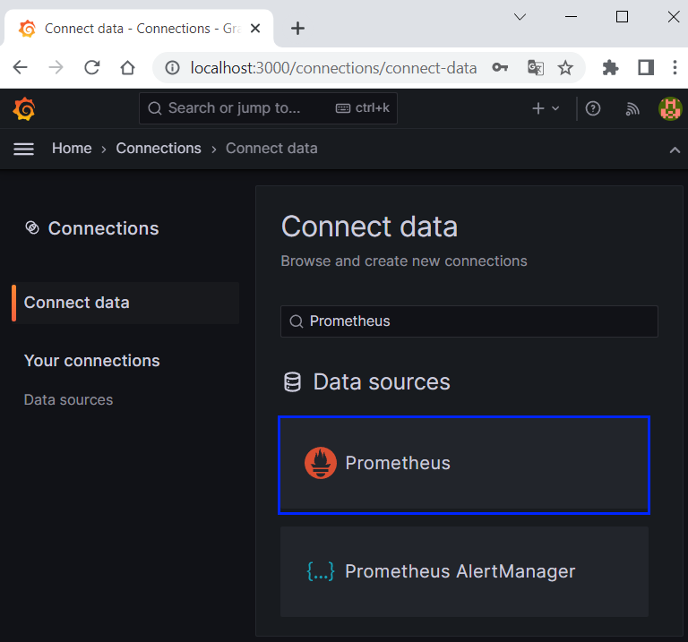

Step 3: Configure Prometheus Data Source
Now, let's create a Prometheus data source:
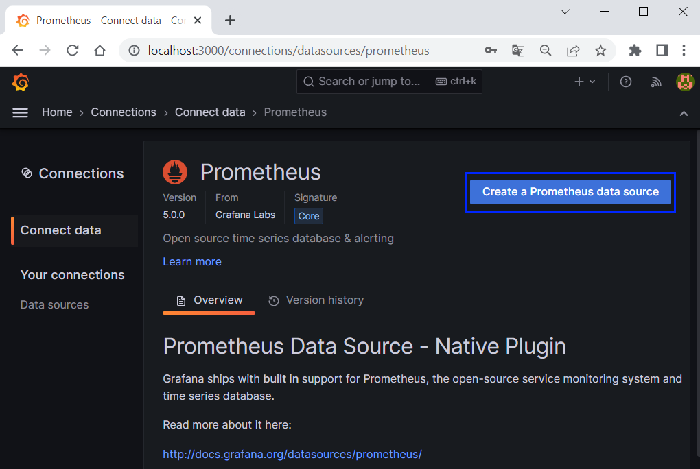
We have to set the Prometheus server URL:
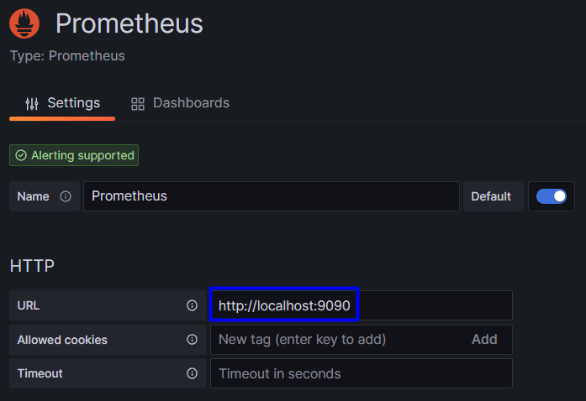
Save the settings by scrolling to the bottom of the page and click on [Save & test]:
You should see the success message in a few moments:


Step 4: Create a Grafana Dashboard
Now, let's create a new dashboard. Go to the left sidebar again and click on [Dashboards]. Click on the [New] button and select [New Dashboard]:
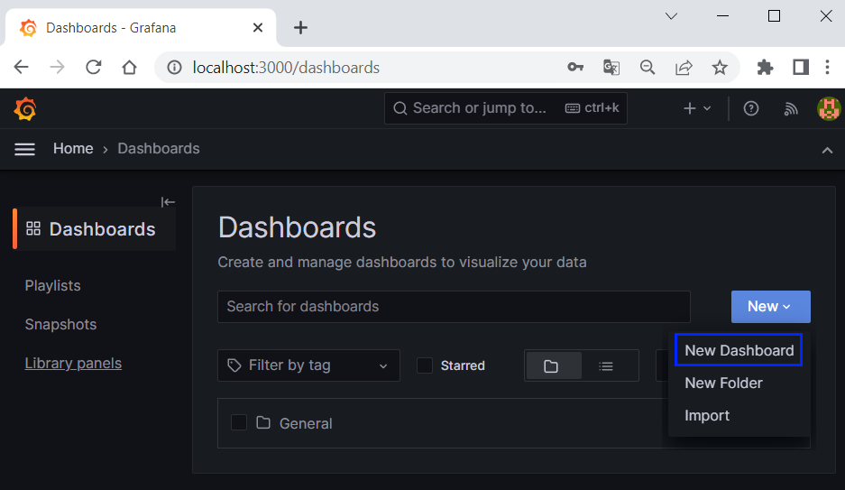
Now, click on the [+ Add visualization] button to create a visualization (panel):
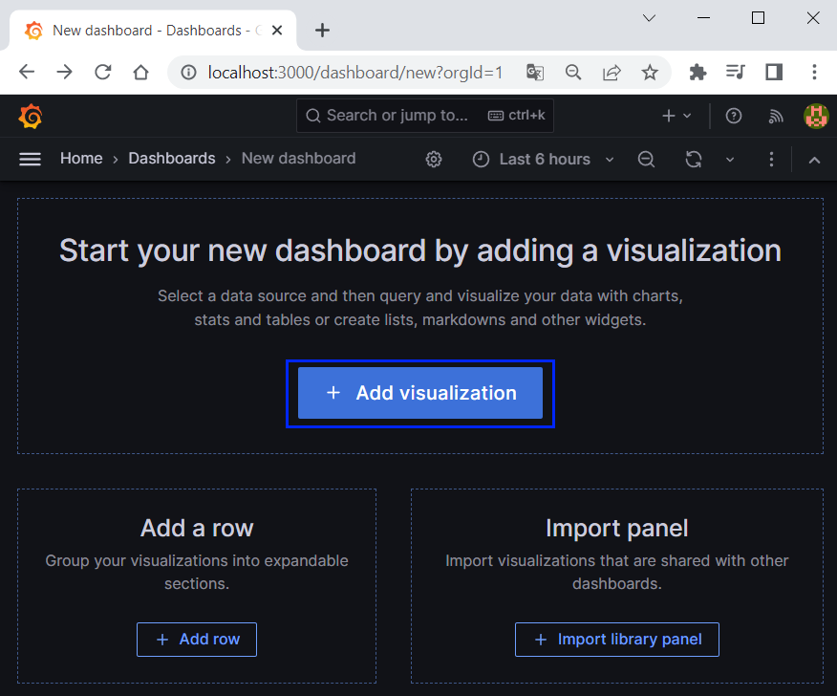
For example, you can create a histogram for the HTTP probe duration metric.
First, select the Prometheus data source from the Data source dropdown menu:
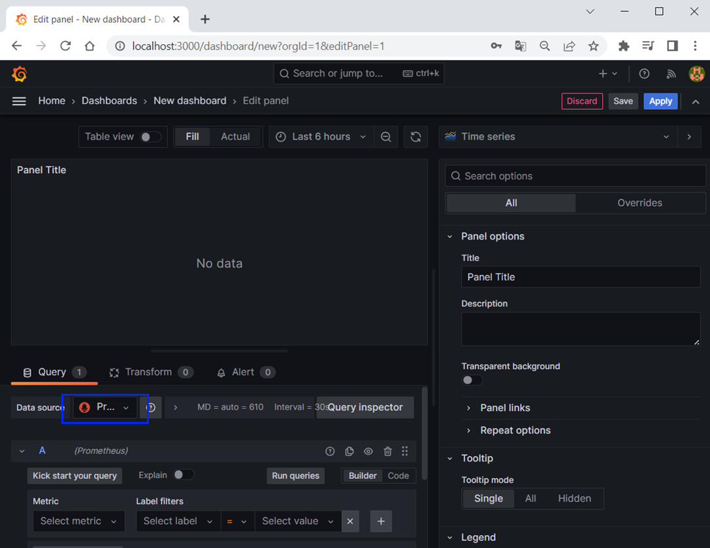
Next, click on the Visualization menu and select Histogram:
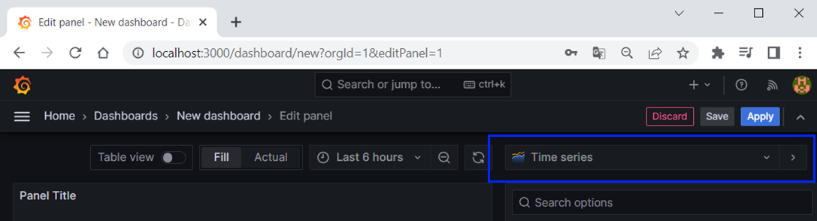 → 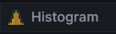
Next, select the metric for lookup:
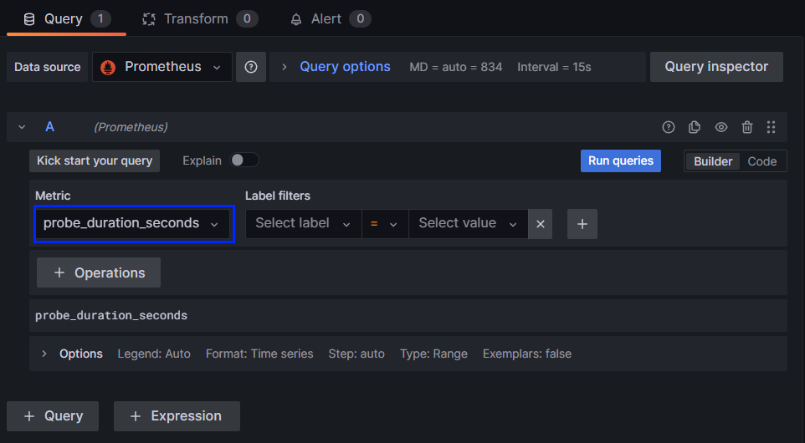
After that, click on the [Run queries] button:
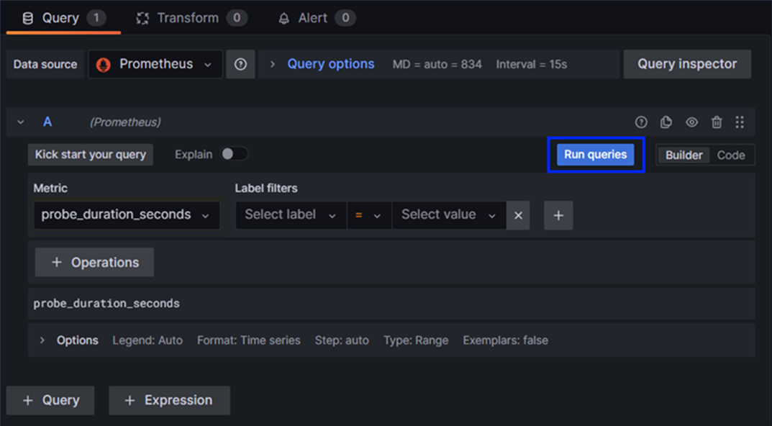
And you should be able to see the panel:
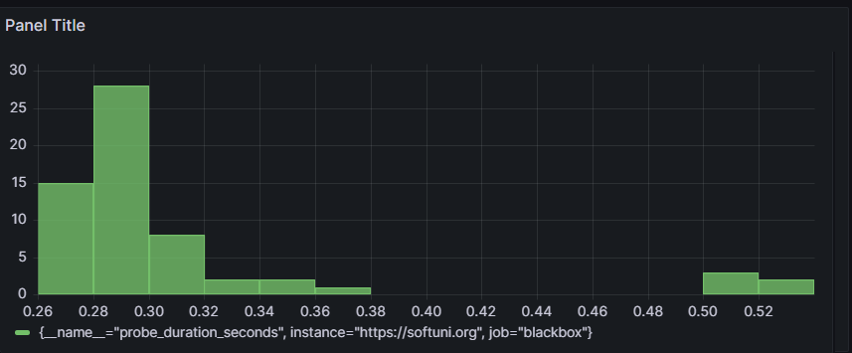
In order to change the panel title, click on the "Title" input field in the Panel options section:
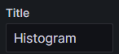

Step 5: Import and Export Dashboards
You can export and import Grafana dashboards as JSON files.
In order to export a dashboard, open Dashboards and then click on [Share]:

Then, click on [Export] → [Save to file]:
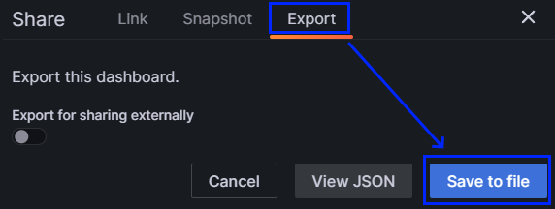
You should be able to save the dashboard as a JSON file
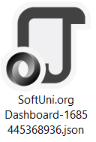 → 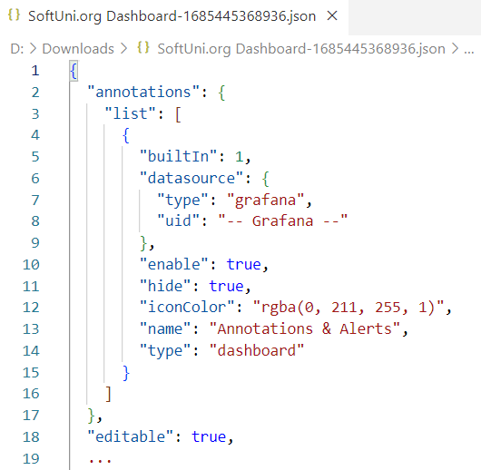
If you want to import a dashboard from a JSON file, go to Dashboards and click on [New] → [Import]:
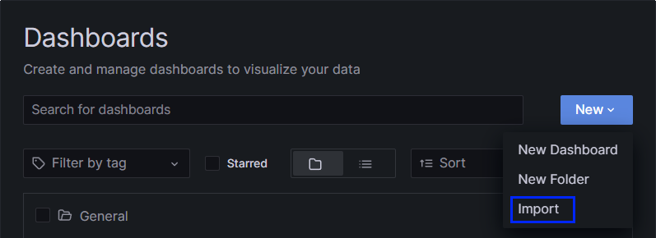
You should be able to see the upload menu. You can choose to drag and drop the JSON file or just upload it:
